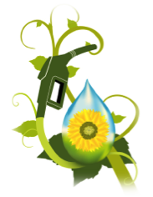
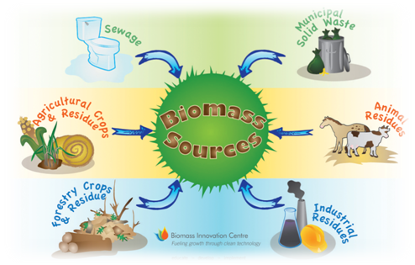
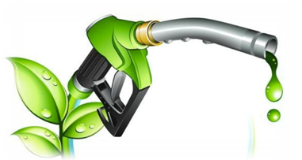
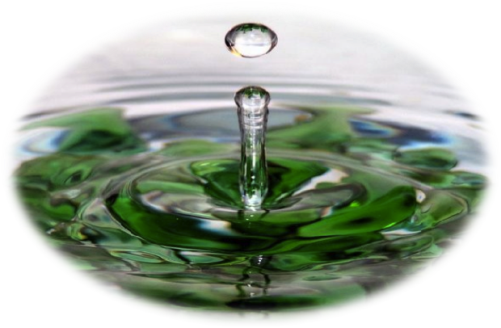
HOW TO SAVE WATER AND PRODUCE ENERGY IN AGRICULTURE?

IN ITALY, OVER 60% OF WATER USE IS RELATED TO AGRICULTURE.

The farm can save water,
but it can also
PRODUCEENERGY!!!

Availability of products (biomass) derived from
agricultural and forestry crops used for the production of electricity and thermal energy and biofuels.
Availability of large areas for the construction of different types of installation for the production of energy (energy crops, photovoltaic, eolic).

… SO WE CAN SAVE WATER EXCERCISING DRY FARMING AND RECOVERING WATER FOR IRRIGATION. WE CAN ALSO PRODUCE ENERGY USING AGRICULTURAL PRODUCTS FOR THE PRODUCTION OF ELECTRICITY AND BIOFUELS

WATER & ENERGY IN AGRICULTURE
METHODS OF MANAGEMENT OF WATER RESOURCES IN AGRICULTURE
WATER SAVING
RECOVERY AND REUSE
- DRY FARMING
- CROP MANAGEMENT AND SELECTION
- AGRONOMIC TECHNIQUES
- INCREASE EFFICIENCY SISTEMS
- WATER RECOVERY
- PURIFICATION
- IRRIGATION WHIT PURIFIED WATER
Aurora M., IIS G. Garibaldi 4°B, A.S. 2013/2014, Water and Energy in Agriculture

